Online Supporting Information—Additional Figures for “Effects of Native Bryophytes on Exotic Grass Invasion: A Test of the Stress Gradient Hypothesis”

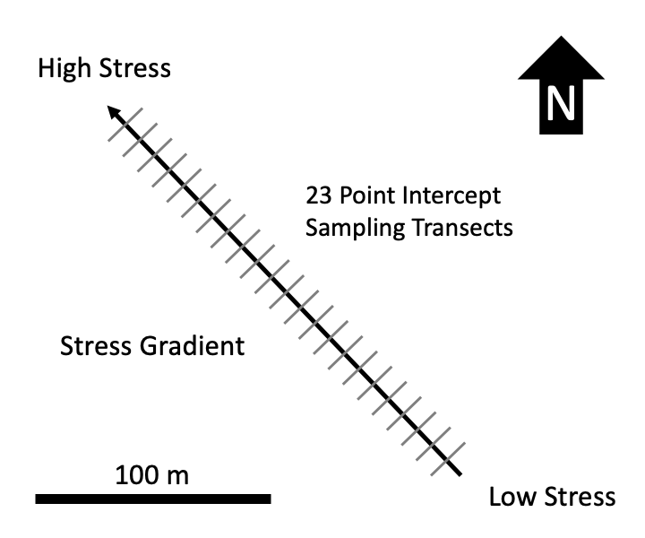

Figure S – Schematic of environmental stress gradient and observational study design. 23 20 m long transects were sampled along the length of the roughly 220 m long stress gradient, running from low stress in the SE and high stress in the NW. Experimental blocks for the moss removal experiment were located on the same transect.

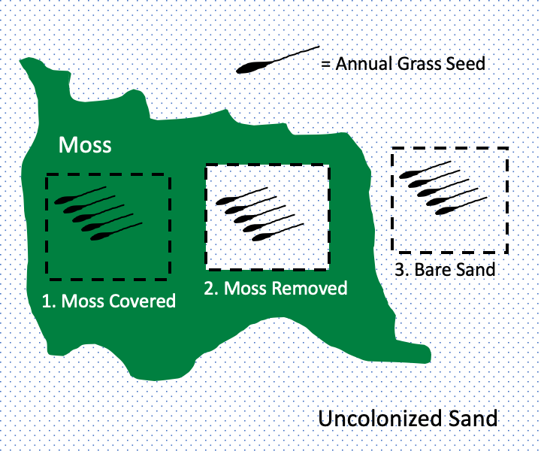

Figure S – One experimental block in the moss removal experiment. Nine experimental blocks were located at the low stress end of the gradient and nine located at the high stress end of the gradient (see fig. S1). Each block was centered on a large moss mat moss and consisted of three experimental patches—a natural moss patch, a patch with moss removed and a bare sand patch outside of moss. Five seeds of exotic annual grasses were planted in each patch. Separate blocks were used for the two different species.

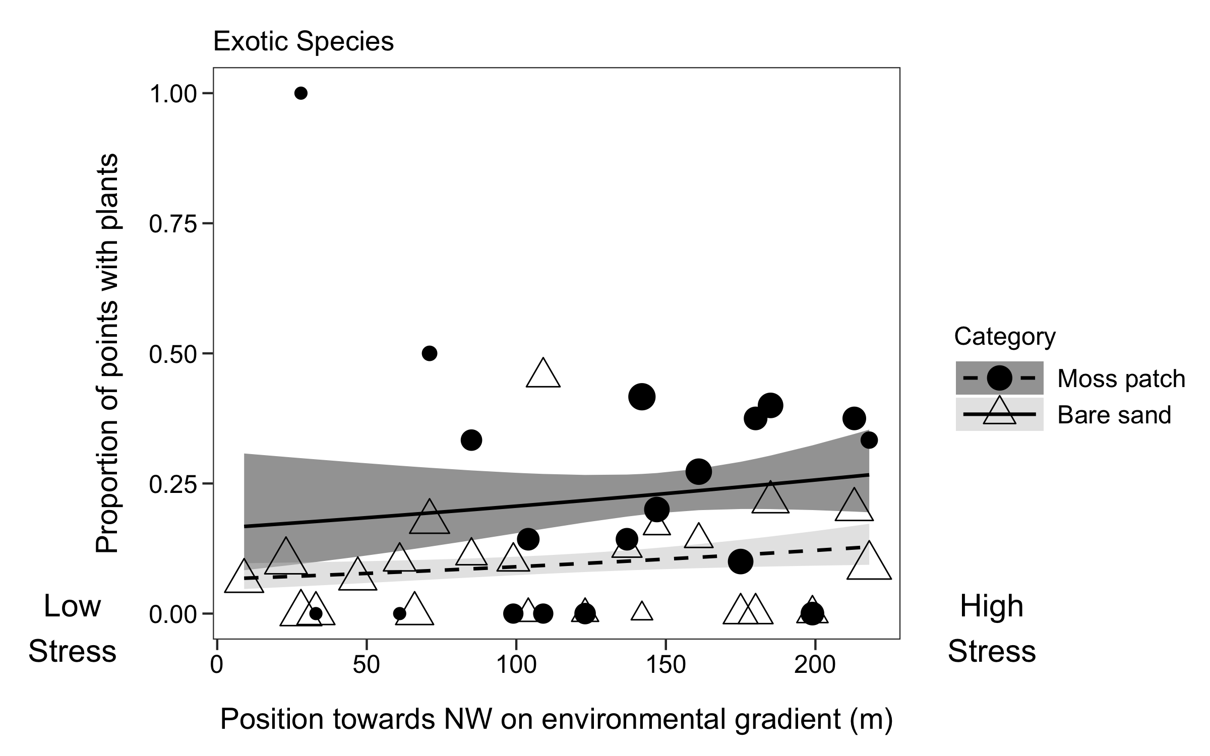

Figure S – Frequency of exotic vascular plants inside and outside of moss patches across the environmental gradient. Y-axis gives proportion of plants rooted within 1 cm of sampling point. Symbol size is scaled to indicate the number of samples within each habitat at each position along the stress gradient—larger symbols indicate larger sample size. Lines and shaded areas show back-transformed means plus or minus standard error from a binomial model. Positions further to the right on the plot correspond to increasing environmental stress.

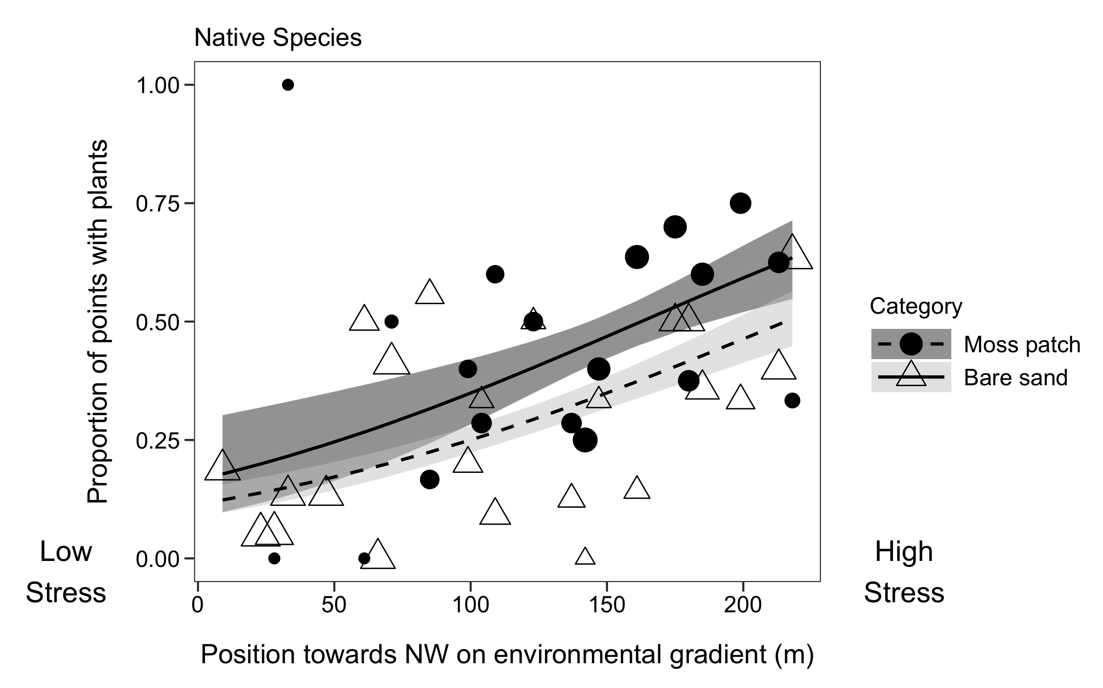

Figure S – Frequency of native vascular plants inside and outside of moss patches across the environmental gradient. Y-axis gives proportion of plants rooted within 1 cm of sampling point. Symbol size is scaled to indicate the number of samples within each habitat at each position along the stress gradient—larger symbols indicate larger sample size. Lines and shaded areas show back-transformed means plus or minus standard error from a binomial model. Positions further to the right on the plot correspond to increasing environmental stress.

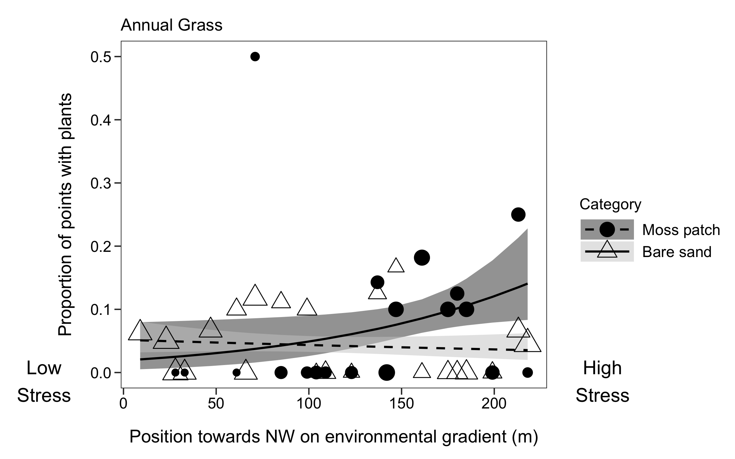

Figure S – Frequency of exotic annual grasses (both *Bromus* and *Vulpia*) inside and outside of moss patches across the environmental gradient. Y-axis gives gives proportion of plants rooted within 1 cm of sampling point. Symbol size is scaled to indicate the number of samples within each habitat at each position along the stress gradient—larger symbols indicate larger sample size. Lines and shaded areas show back-transformed means plus or minus standard error from a binomial model. Positions further to the right on the plot correspond to increasing environmental stress.